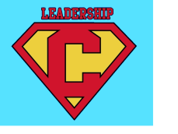
Be a Leadership Kid…not just a
Kid in Leadership

Leadership Kid (Awesome) Kid In Leadership (Not so Awesome)
_________________________ _____

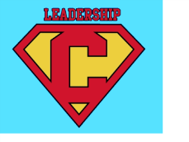
Be a Leadership Kid…not just a
Kid in Leadership

Leadership Kid (Awesome) Kid In Leadership (Not so Awesome)
_________________________ _____

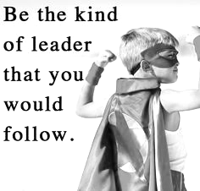
3 Goals I Have For Myself In Leadership This Year

- _____________________________________________________________________________________________________________________________________________________________________________________________
- _____________________________________________________________________________________________________________________________________________________________________________________________
- _____________________________________________________________________________________________________________________________________________________________________________________________

3 Goals I Have For Myself In Leadership This Year

- _____________________________________________________________________________________________________________________________________________________________________________________________
- _____________________________________________________________________________________________________________________________________________________________________________________________
- _____________________________________________________________________________________________________________________________________________________________________________________________

